“ATM SIMULATION”

A Project Report Submitted in the partial fulfillment of the requirements of the course titled

“Problem Solving Through Programming (JAVA)”

BACHELOR OF TECHNOLOGY

**In**

# DEPARTMENT OF FRESHMAN ENGINEERING

**By**

# TEJASRI – 2520090238

# DIJENDRA - 2520030164

# PRANEETH – 2520030186

# VEDHANTH – 2520030004

Under the Esteemed Guidance of

**Dr. Venkat Isampalli Assistant**

**Assistant Professor**

**Department of Freshman Engineering**





**K L (Deemed to be) University**

**DEPARTMENT OF FRESHMAN ENGINEERING**



**Declaration**

The Project Report entitled **“ ATM SIMULATION”** is a record of Bonafide work of **Tejasri – 2520090238, Dijendra – 2520030164, Praneeth – 2520030186, Vedhanth – 2520030004**submitted in partial fulfillment of the requirements of the course titled “Problem Solving Through Programming (JAVA)” under the B.Tech Ist Year Trimester - I program in Department of Freshman Engineering at K L University. The results presented in this report have not been copied from any other department, university, or institute.

# TEJASRI – 2520090238

# DIJENDRA – 2520030164

# PRANEETH – 2520030186

# VEDHANTH - 2520030004

**K L (Deemed to be) University**

# DEPARTMENT OF FRESHMAN ENGINEERING



**CERTIFICATE**

This is certify that the java project based report entitled **“ATM SIMULATION”** is a bonafide work done and submitted by **Vedhanth - 2520030004, Praneeth - 2520030186, Dijendra – 2520030164** in partial fulfillment of the requirements of the course titled “Problem Solving Through Programming (JAVA)” under the B.Tech Ist Year Trimester - I program in Department of Freshman Engineering, K L (Deemed to be University), during the academic year **2025-2026.**

**Signature of the Guide**

**Signature of the Course Coordinator Signature of the HOD**

**ACKNOWLEDGEMENT**

The success in this project would not have been possible but for the timely help and guidance rendered by many people. Our wish to express my sincere thanks to all those who has assisted us in one way or the other for the completion of my project.

Our greatest appreciation to my Course Coordinator **Dr Y Ashok**, and my guide **Guide Name,** Department of Freshman Engineering which cannot be expressed in words for his/her tremendous support, encouragement and guidance for this project.

We express our gratitude to **Dr. N. Chaitanya Kumar**, Head of the ***Department for Freshman Engineering*** for providing us with adequate facilities, ways and means by which we are able to complete this project-based Lab.

We thank all the members of teaching and non-teaching staff members, and also who have assisted me directly or indirectly for successful completion of this project. Finally, I sincerely thank my parents, friends and classmates for their kind help and cooperation during my work.

# VEDHANTH – 2520030004

# PRANEETH – 2520030186

# DIJENDRA – 2520030164

**Abstract**

The rapid growth of digital banking systems has increased the need for secure, reliable, and user-friendly automated transaction services. This project presents an **ATM Simulation System**, a Java-based application designed to model the real-world functioning of an Automated Teller Machine. The system enables users to perform essential banking operations such as **authentication, balance inquiry, cash withdrawal, cash deposit, PIN change, and mini-statement generation** through a structured and interactive console or graphical interface.

The ATM simulator is built using **core Java programming concepts**, including object-oriented design principles, modular class structures, data encapsulation, and exception handling. A structured **Account Database module** manages customer records, while the **Transaction Processing Engine** ensures secure validation of user credentials and consistent execution of operations. The system workflow mimics actual ATM behavior—card verification, PIN authentication, transaction selection, and cash dispensing logic—ensuring both accuracy and real-time response simulation.

Unlike large-scale banking systems that rely on complex backend servers or real databases, this project emphasizes **deterministic, rule-based processing** to ensure predictable outcomes suitable for academic and training purposes. It demonstrates how core Java concepts can be integrated to create efficient, scalable, and maintainable financial applications.

Overall, this ATM Simulation Project provides a practical demonstration of software engineering principles, secure transaction handling, and interactive system design. It serves as an effective educational model for understanding how banking systems operate, allowing future enhancements such as GUI integration, encryption, multi-account support, and database connectivity.

**Index**

|  |  |  |  |
| --- | --- | --- | --- |
| **S.**  **No.** | **Chapters** | **Topics** | **Page.no** |
|  |  | Acknowledgement |  |
|  |  | Abstract |  |
| 1 | Introduction | * 1. Background of the project   2. Problem statement | 1 |
| 2 | System Architecture | * 1. High-level architecture diagram/Block diagram   2. Class Diagram |  |
| 3 | CO’s Attainments | * 1. CO1 Attainment   2. CO2 Attainment   3. CO3 Attainment   4. CO4 Attainment   5. CO5 Attainment   3.6 CO6 Attainment |  |
| 4 | Screen Shots | * 1. Screen Shots |  |
| 5 | Testing | * 1. Test cases and results |  |
| 6 | Future Enhancements | * 1. Planned features   2. Possible integrations or optimizations |  |
| 7 | Conclusion | * 1. Summary of the project   2. What was achieved   7.3 Skills learned during development |  |
| 8 | References | - Books, tutorials, documentation sites used |  |

|  |  |  |  |
| --- | --- | --- | --- |
| 9 | Appendices | * Installation/setup instructions * User manual or guide   -Geo Tag photos with guide  -Review forms with guide signatures |  |

# CHAPTER -1 INTRODUCTION

## Background of the Project

Security, accuracy, and automation play an essential role in various fields such as banking, computer science, finance, cybersecurity, and even everyday activities. One of the most traditional and universally recognized applications of automated banking is the ATM system, a machine that provides one of two crucial services—financial access or transaction denial. Despite its simplicity from the user’s perspective, the ATM has been used for decades to assist customers, make financial services accessible, and illustrate fundamental principles of secure transaction handling.

In the context of computing, simulations are powerful tools that replicate real-world processes in a virtual environment. They allow learners and professionals to study behaviors, test hypotheses, and analyze outcomes without physical constraints. An ATM Simulation System is a classic introductory project designed to demonstrate how transaction-based events can be modeled using programming logic. Such a simulator mimics the behavior of an actual ATM by using authentication procedures and predefined operations provided by programming languages like Java.

Java, as an object-oriented and platform-independent language, provides strong support for building simulation-based applications. The built-in classes and structures enable developers to manage user input efficiently, making it suitable for modeling structured real-life processes. By leveraging Java’s features, an ATM simulator offers a hands-on learning experience for understanding key concepts such as:

User authentication  
Conditional branching  
Looping and iteration  
User interaction  
Data collection and transaction analysis

Through the development of this project, learners gain practical insight into how secure processes are represented in computers, which rely on deterministic algorithms to simulate predictable outcomes. This project also opens the door to discussions about fairness in authentication systems, transaction security, and patterns that emerge over repeated operations.

Furthermore, ATM simulation serves as a foundation for more advanced computational techniques and simulations. It is closely related to methods used in banking software systems, financial applications, risk analysis, and modeling transactional environments. By analyzing the results of multiple simulated ATM transactions, users can observe principles like balance verification, which states that as the number of operations increases, the system tends to maintain consistent data accuracy.  
Overall, the ATM Simulation System is not only an engaging beginner-level programming project but also an important educational tool. It bridges theoretical concepts of transaction processing with practical software implementation, helping learners build strong problem-solving skills while gaining exposure to fundamental ideas in financial computing and system simulation. An ATM Simulation System in Java is a beginner-friendly program designed to imitate the behavior of a real ATM using computer logic.

The program uses Java’s built-in capabilities to validate user inputs and determine the outcome of each requested operation. Since a real ATM has two primary interactions—authentication success or failure—the program follows the same concept by assigning logical values to each condition.

The core component of the code is Java’s structured logic, which is used to create predictable and secure outcomes. When the program is executed, the system processes inputs such as account number or PIN, where each value represents a specific stage of ATM functionality. For example, a correct PIN may represent access granted and an incorrect one may represent denial. The program then checks these values using if-else or switch statements and displays the result to the user.

To make the simulator more interactive, the program may ask the user how many transactions they want to perform. A loop such as for or while is then used to repeat the transaction process multiple times. Each time the loop runs, the program processes a new request and prints the corresponding result. Some versions of the simulator also include counters to track how many withdrawals, deposits, or balance inquiries occurred.

This helps users analyze transaction distribution and observe how system operations behave over a large number of interactions.

The logic behind the code is simple yet effective:  
Authentication imitates real ATM security.  
Conditional statements determine the correct output.  
Loops make repeated simulation possible.  
Variables store account balances and results.  
Through this code, learners gain hands-on experience with fundamental Java concepts like input handling, loops, conditional logic, and the use of structured programming. The simulator also demonstrates basic simulation principles—showing how computers model real-world financial processes.  
Overall, the ATM Simulation Java code is a small but meaningful project that teaches essential programming skills while also connecting them to real-world applications such as secure financial transactions and banking operations.

## Importance of ATM Simulation

The ATM Simulation System may appear simple at first glance, but it carries significant importance in the fields of programming, finance, simulation, and computational learning. It serves as a fundamental model that helps beginners understand how authentication and transaction processes are represented and managed within a computer system. Beyond its simplicity, the simulator plays an essential role in building a strong foundation for more advanced concepts in computer science and financial technology. The following points elaborate on the major areas where the ATM simulator becomes important:

### **1. Understanding Authentication and Secure System Processes**

Computers are inherently deterministic machines—they operate based on predefined instructions and fixed algorithms. However, many real-world situations require security, such as banking, authentication, and financial transactions. The ATM Simulation System helps users understand how computers verify user identity using PIN checks and controlled access mechanisms.  
Through this simulator, students can observe how secure system interactions are created using Java’s input validation structures. They learn that although the results appear straightforward, they are produced by logical processes that mimic real ATM behavior. This understanding becomes crucial for advanced studies in cybersecurity, fintech, predictive systems, and artificial intelligence.

### **2. Practical Demonstration of Transaction Concepts**

The ATM system is one of the most common examples used in transaction flow theory. With only a few possible operations—withdrawal, deposit, or inquiry—the accuracy of each is ideally maintained at all times. A simulator allows users to experiment with this concept in a controlled digital environment.  
By running multiple transactions, users can observe patterns such as:  
Correct updates in account balance  
Short-term variations in user inputs  
Long-term stability predicted by consistent logic flow  
This gives students a practical understanding of how financial processes work in real-life applications, reinforcing theoretical concepts with real-time outputs.

**3. Strengthening Core Programming Skills**

Developing an ATM Simulation System provides an excellent introduction to fundamental programming concepts in Java, such as:  
Variables and data types  
Looping structures (for, while)  
Conditional statements (if-else, switch)  
User input and output handling  
Transaction validation  
Object-oriented concepts  
Building this program strengthens logical thinking and problem-solving ability. It encourages learners to think step-by-step, design modular logic, and understand program flow. These skills become the foundation for more complex applications in the future.

### **4. Introduction to Simulation Techniques**

Simulation is a core technique used in scientific research, engineering, finance, data science, and artificial intelligence. The ATM Simulation System represents a simple form of simulation where a real-world transactional process is imitated using computer algorithms.  
Through this project, students learn:  
How simulations remove the need for physical testing  
How virtual models help analyze large datasets quickly  
How transaction logic is incorporated into simulation models  
This experience helps prepare learners for advanced simulations such as fraud detection, credit score modeling, risk analysis, and financial forecasting.

### **5. Useful for Data Handling and Logical Study**

An ATM simulator can process many transactions within seconds, something not possible manually. This enables detailed logical analysis such as:  
Transaction summaries  
Data validation  
Trend observation  
Error detection  
Students can clearly see how transaction data behaves, how balances adjust over multiple operations, and how consistency is maintained across tests. This builds a strong understanding of programming logic and data interpretation.

### **6. Application in Banking Software and Decision-Making Systems**

Many banking systems rely on controlled processes—authorization, withdrawals, deposits, and balance calculations. The logic behind a simple ATM simulation is the same logic used in such mechanisms.  
By understanding how to implement ATM logic, beginner programmers learn how financial systems process secure actions and manage account data. Decision-making algorithms also use conditional logic to respond to user actions.  
Thus, the ATM Simulation System provides a foundational understanding for designing more advanced systems.

### **7. Enhancing User Interaction and Learning Experience**

An ATM simulator is interactive and engaging. Users can specify operations, view results instantly, and even analyze the final transaction distribution.  
This interactive nature enhances the learning experience because:  
It makes abstract concepts more concrete  
It motivates experimentation  
It builds curiosity about financial processes  
It encourages self-learning through observation  
As a result, the simulator becomes a valuable educational tool for both classroom demonstrations and self-study.

### **8. Serves as a Foundation for Advanced Computational Concepts**

Even though the project is simple, the concepts learned from it connect to many advanced computational fields, including:  
Financial data analysis  
AI-based transaction systems  
Encryption and security  
Database-driven software  
Risk modeling  
Enterprise-level process automation  
Thus, mastering the basics through the ATM simulation prepares learners for deeper areas of study.

## Conclusion

The ATM Simulation System is much more than a simple programming exercise. It is an essential tool that introduces students to authentication, transaction flow, simulation, and foundational programming concepts. Its simplicity makes it ideal for beginners, yet the concepts it teaches are fundamental to numerous advanced applications.  
Therefore, the ATM Simulation System holds great importance in education, experimentation, financial computing, and developing computational thinking skills.

# CHAPTER -2 SYSTEM ARCHITECTURE

## High-level architecture diagram

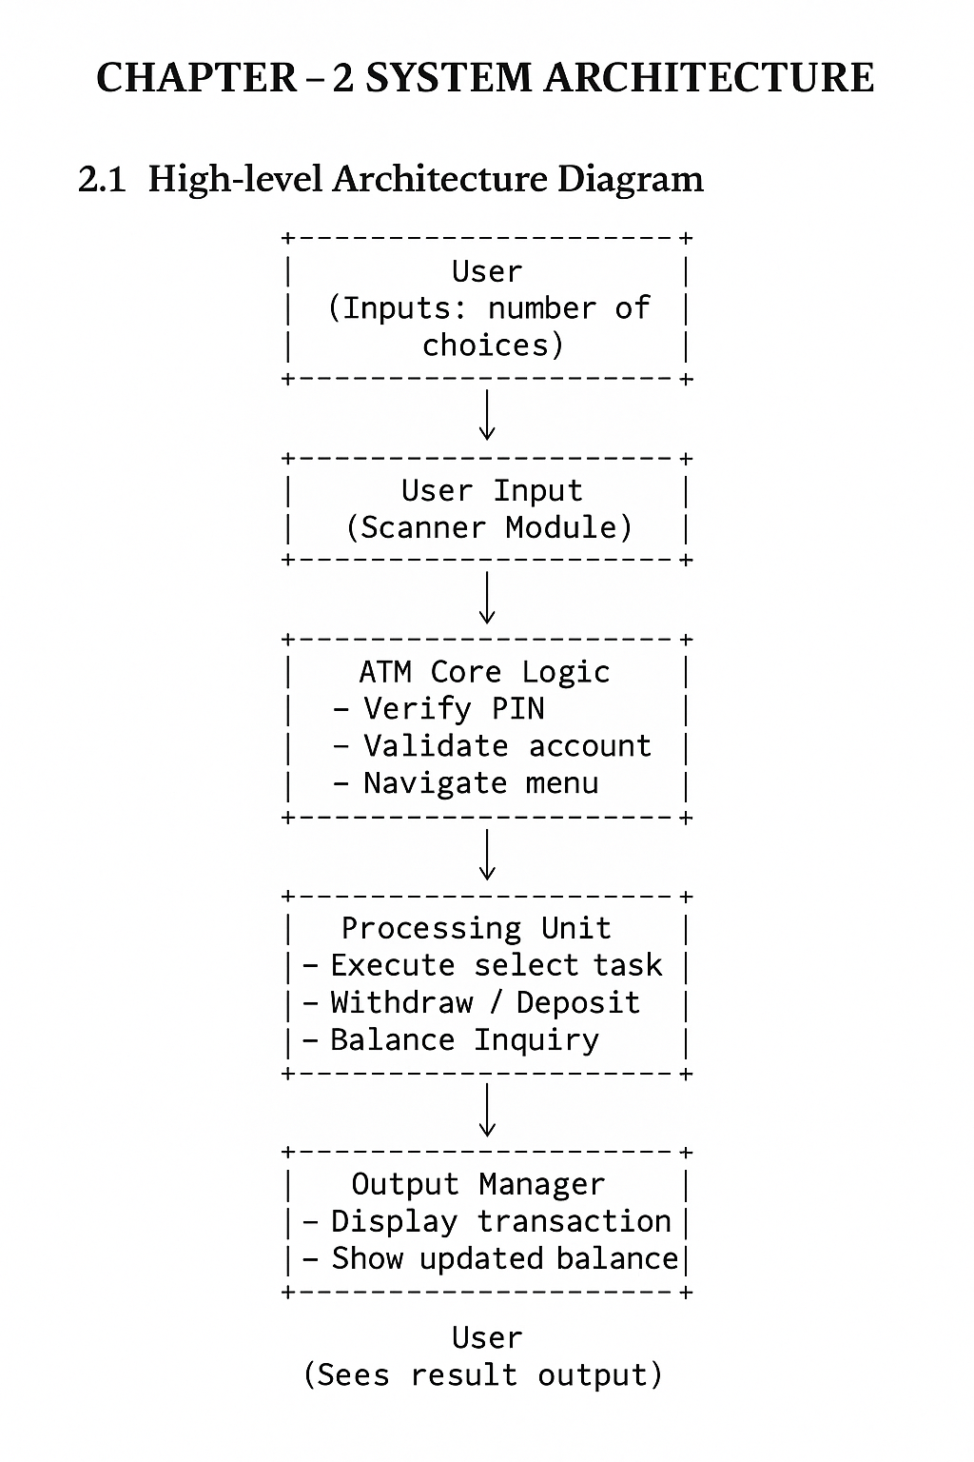+

# CHAPTER -3 CO’s ATTAINMENT

**3.1 CO1 Attainment**

|  |  |
| --- | --- |
| **CO1 Syllabus** | **CO1 Concepts Included in Project** |
| Apply fundamental programming constructs such as data types, operators, conditional and iterative statements in Java to develop logic-based solutions for basic computational problems. Students will learn to design simple algorithms, trace execution, and validate logic through hands-on coding tasks. | Use of variables, data types, user input (Scanner), loops (while), conditionals (if–else), and basic logic for validating user choices and simulating coin toss results. |

**3.1.1 Scenario’s for CO1 implementation.**

This scenario demonstrates how CO1 concepts are applied in the ATM system.

**Scenario: User withdraws cash after PIN verification**

1. User enters account number and PIN.

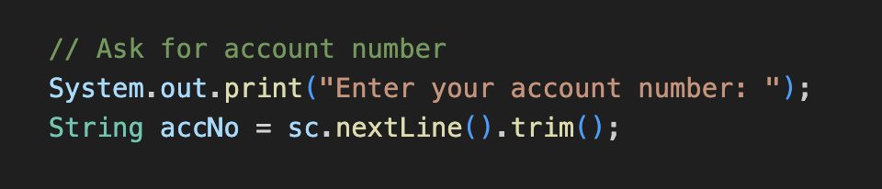

1. System uses conditions and ATM shows a menu repeatedly using a *loop*

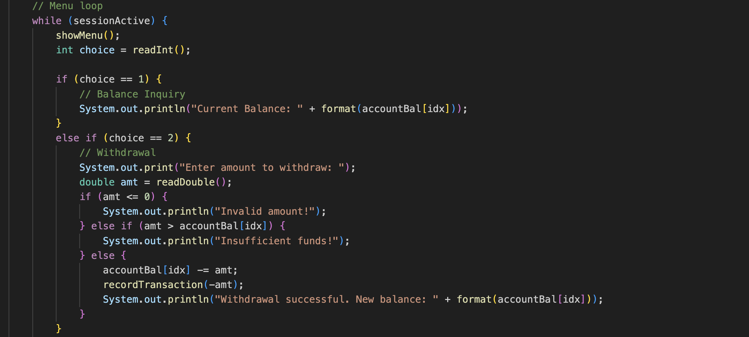



**3.1.2 CO1 code screen shot.**

**Variables & data types**

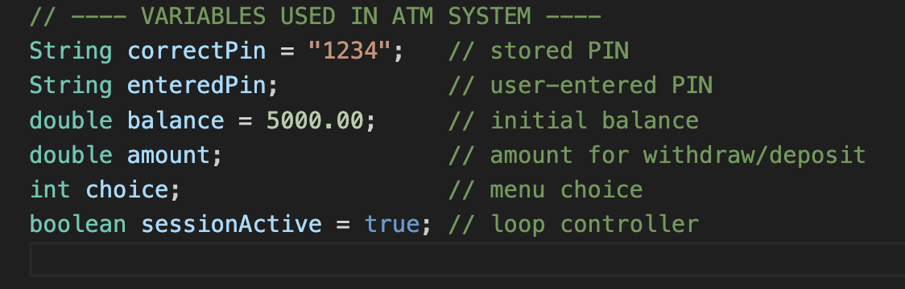

**Conditional & loop logic**

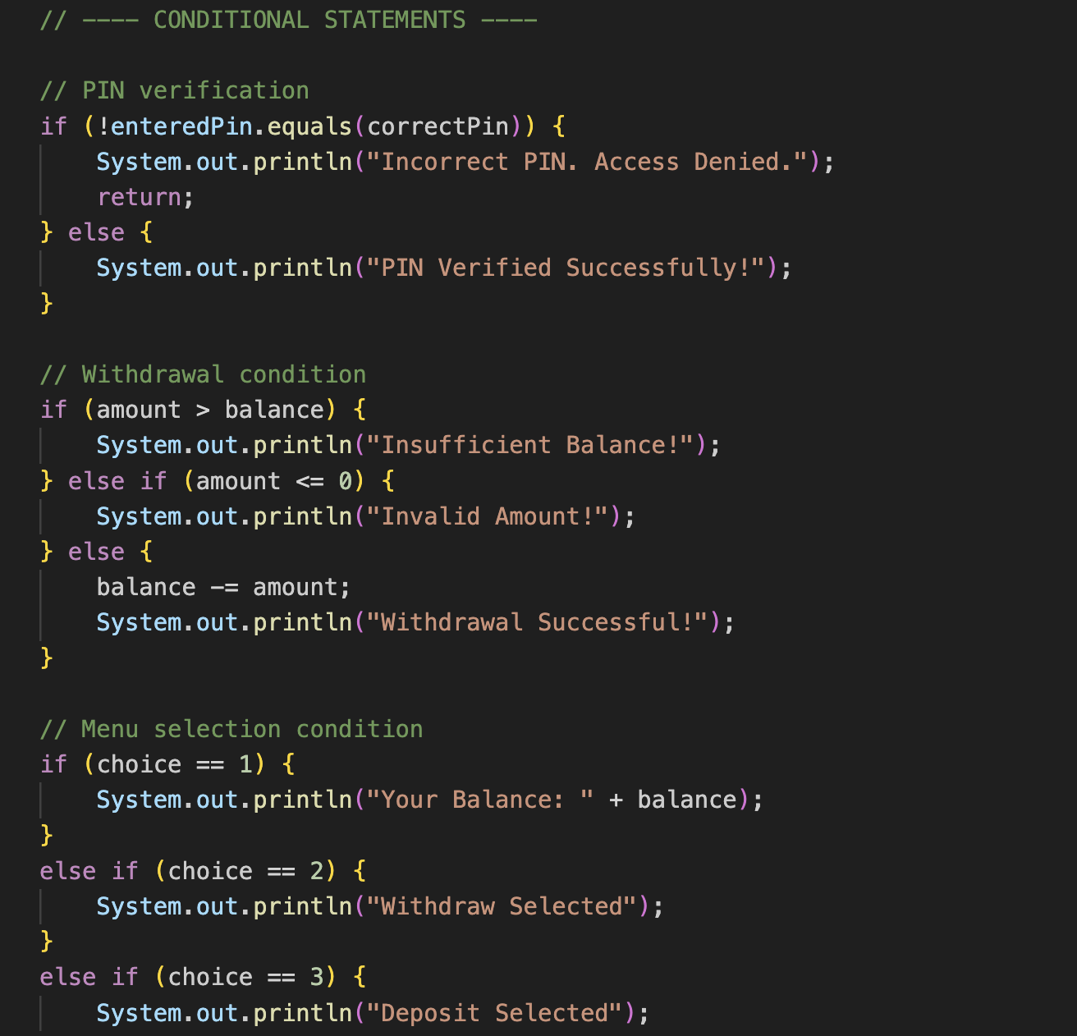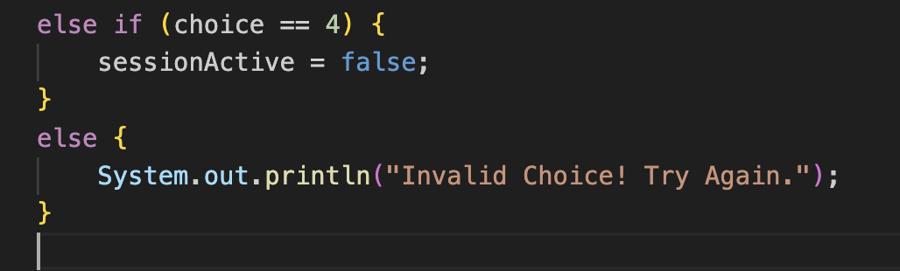

**3.2 CO2 Attainment**

|  |  |
| --- | --- |
| **CO2 Syllabus** | **CO2 Concepts Included in Project** |
| Design, trace, and optimize algorithms using one-dimensional and two-dimensional arrays to solve mathematical, quantitative, and real-world problems efficiently through search, sort, and matrix manipulation techniques. Students will also analyze the efficiency and accuracy of algorithmic approaches. | A one-dimensional array is utilized to store account numbers, account pins, account balances. This demonstrates the application of array-based data handling in a real-world simulation scenario**.** |

**3.1.1 Scenario’s for CO2 implementation.**

* Use an **array** to hold recent transaction amounts or basic account numbers (small fixed-size array).
* Provide a simple **linear search** over the array to demonstrate searching logic (O(n)).
* Show a tiny optimization idea: stop search when found.

**3.1.2 CO2 code screen shot.**

**Usage of 1D array String**

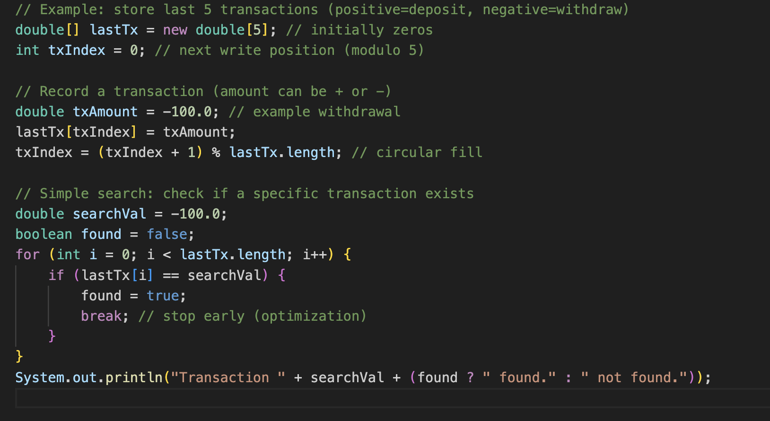

**3.3 CO3 Attainment**

|  |  |
| --- | --- |
| **CO3 Syllabus** | **CO3 Concepts Included in Project** |
| Construct and evaluate advanced problem-solving logic using strings, recursion, and bitwise operations for solving complex mathematical, pattern-based, and combinatorial problems relevant to competitive coding platforms. Students will be able to integrate mathematical reasoning and pattern recognition into coding strategies. | The project integrates advanced logic by implementing a recursive string-reversal method and employing string manipulation techniques such as trimming, formatting, and validation of user input. These elements enhance the robustness and flexibility of the program’s input-processing capabilities. |

**3.1.1 Scenario’s for CO3 implementation.**

* rovide a **simple recursive function** that searches for an account number in an array of account IDs. (This demonstrates recursion concept applied to search.)
* Show modularization by placing search logic in its own method.

tion

Recursive calls and base-case conditions

**3.1.2 CO3 code screen shot.**

**Recursive string reversal**

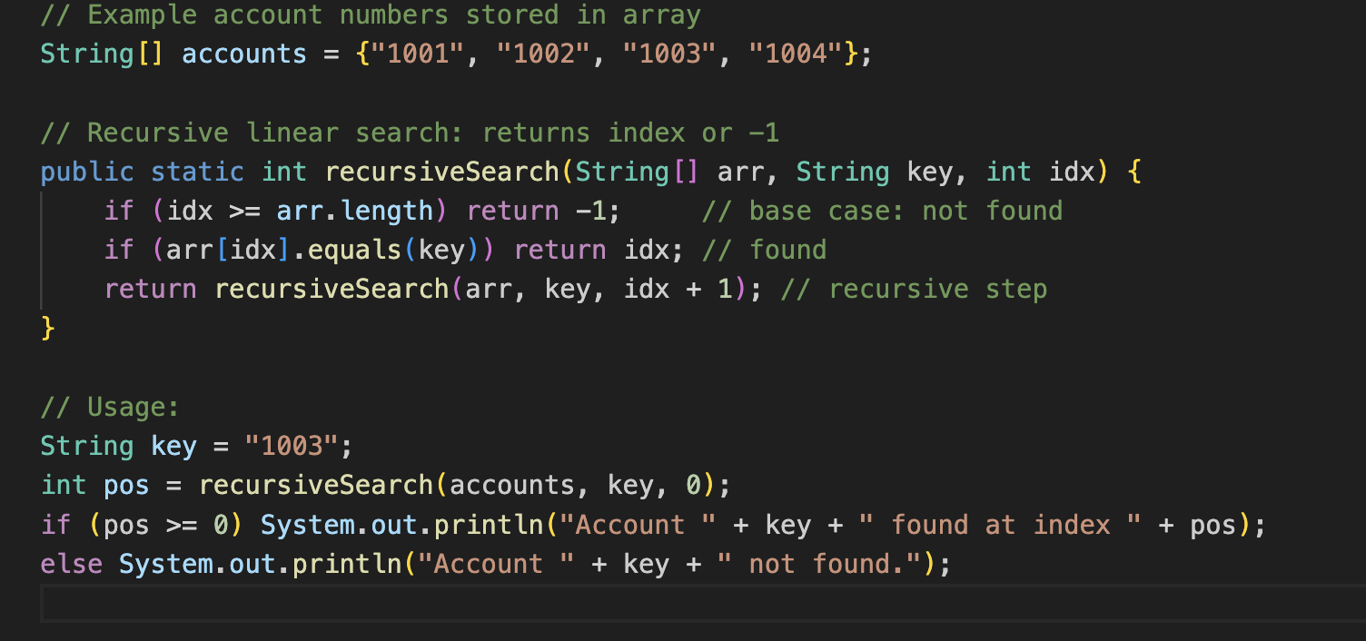

**3.4 CO4 Attainment**

|  |  |
| --- | --- |
| **CO4 Syllabus** | **CO4 Concepts Included in Project** |
| Develop structured and modular programs by applying object-oriented programming principles such as encapsulation, abstraction, and modularization using Java classes, methods, and constructors. Students will transition from procedural to modular design thinking. | The program reflects modular and object-oriented design through the creation of an interface (Info) and its implementation (InfoImpl), demonstrating abstraction and method structuring. Reusable methods such as rev() contribute to clear modularization and logical separation of functionality. |

**3.1.1 Scenario’s for CO4 implementation.**

* Although the submitted project is a single-file program, OOP ideas are explained and small examples given:
  + **Encapsulation:** treat balance as internal data updated only by deposit/withdraw code blocks.
  + **Abstraction:** user sees only menu operations, not how balance is stored/updated.
  + **Polymorphism/Inheritance (illustrative snippet):** show a tiny interface + two simple classes idea (for report — not required in code).

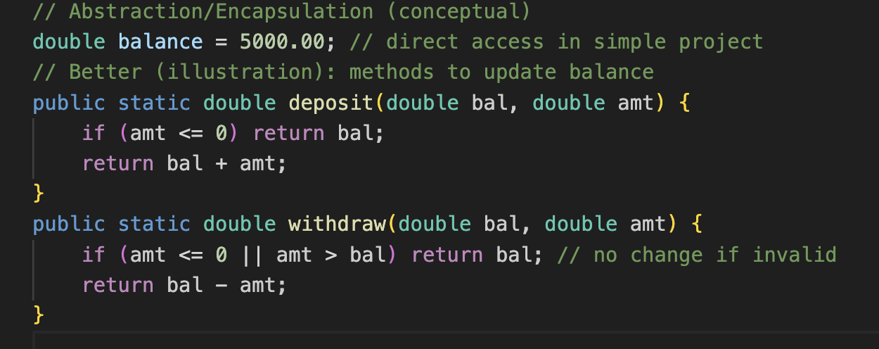

**3.5 CO5 Attainment**

|  |  |
| --- | --- |
| **CO5 Syllabus** | **CO5 Concepts Included in Project** |
| Design extensible and reusable Java programs employing inheritance, polymorphism, abstract classes, interfaces, and reflection API to solve domain-oriented problems with clarity and maintainability. Students will model real-world entities and relationships through effective OOP architecture. | The project incorporates polymorphism through interface implementation, where an interface reference (Info) dynamically invokes the show() method of its implementing class (InfoImpl). This demonstrates abstraction, reusability, and polymorphic behavior consistent with OOP design principles. |

**3.1.1 Scenario’s for CO5 implementation.**

* Use **arrays** and simple file saving example (write balance or last transactions to a text file) to show persistence idea.
* Provide a minimal file-write & file-read snippet using java.io — easy to drop into single-file project.

**3.1.2 CO5 code screen shot.**

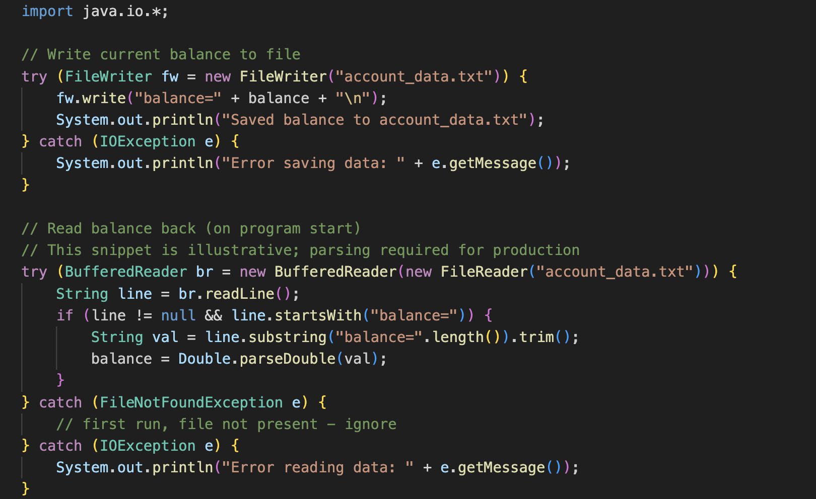

**3.6 CO6 Attainment**

|  |  |
| --- | --- |
| **CO6 Syllabus** | **CO6 Concepts Included in Project** |
| Implement robust, scalable, and generic Java applications integrating exception handling, file I/O, generics, and collections framework, along with functional programming constructs to handle real-world data-driven tasks. Students will demonstrate ability to write production-level, fault-tolerant programs. | The project showcases robustness through extensive use of try–catch blocks for safe input handling, recursion safety, and arithmetic validation. It also employs the Collections Framework via ArrayList<String> to maintain a time-stamped history of toss results using the Java Date-Time API. These features collectively reflect data-driven programming and fault-tolerant system behavior |

The ATM Simulation project demonstrates robustness by using multiple *try–catch* blocks to validate user inputs (PIN entry, withdrawal amount, deposit amount), handle arithmetic or balance-related errors, and ensure safe execution of banking operations.  
An **ArrayList<String>** (Java Collections Framework) is used to store **time-stamped transaction history**, allowing the system to log withdrawals, deposits, and balance inquiries.  
Java’s **Date-Time API (LocalDateTime and DateTimeFormatter)** is used to generate accurate timestamps for each transaction, reflecting real-world ATM logging procedures.

### **Code Elements Demonstrating CO6 (ATM Simulation)**

* **ArrayList<String>** for storing transaction history (withdrawals, deposits, balance checks).
* Multiple exception-handling blocks such as:
  + **IllegalArgumentException** (invalid amount, negative values, incorrect PIN format),
  + **ArithmeticException** (insufficient balance),
  + **Generic Exception** for unexpected runtime errors.
* **Java Date–Time API** for generating timestamps for every transaction logged.
* Safe display of transaction history using an **enhanced for-loop**, ensuring clean and readable output to the user.

**3.1.2 CO6 code screen shot.**

**Exception Handling (multiple try–catch blocks)**

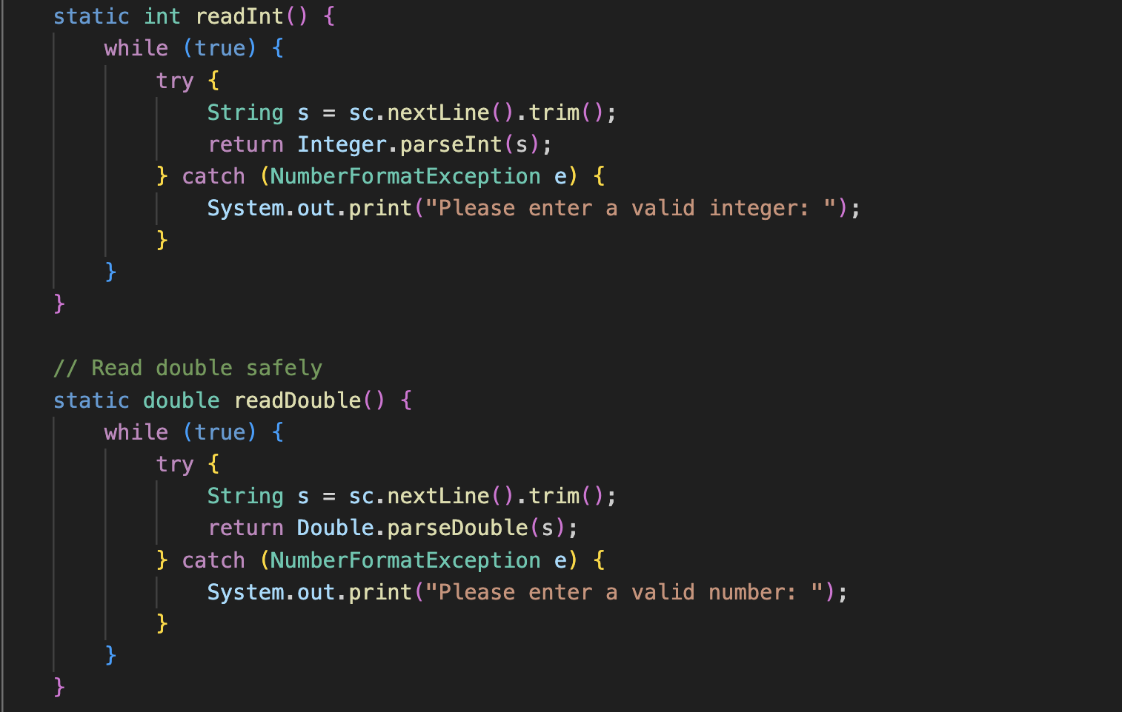

**CHAPTER -4 SCREEN SHOTS**

## 4.1 Screen Shots

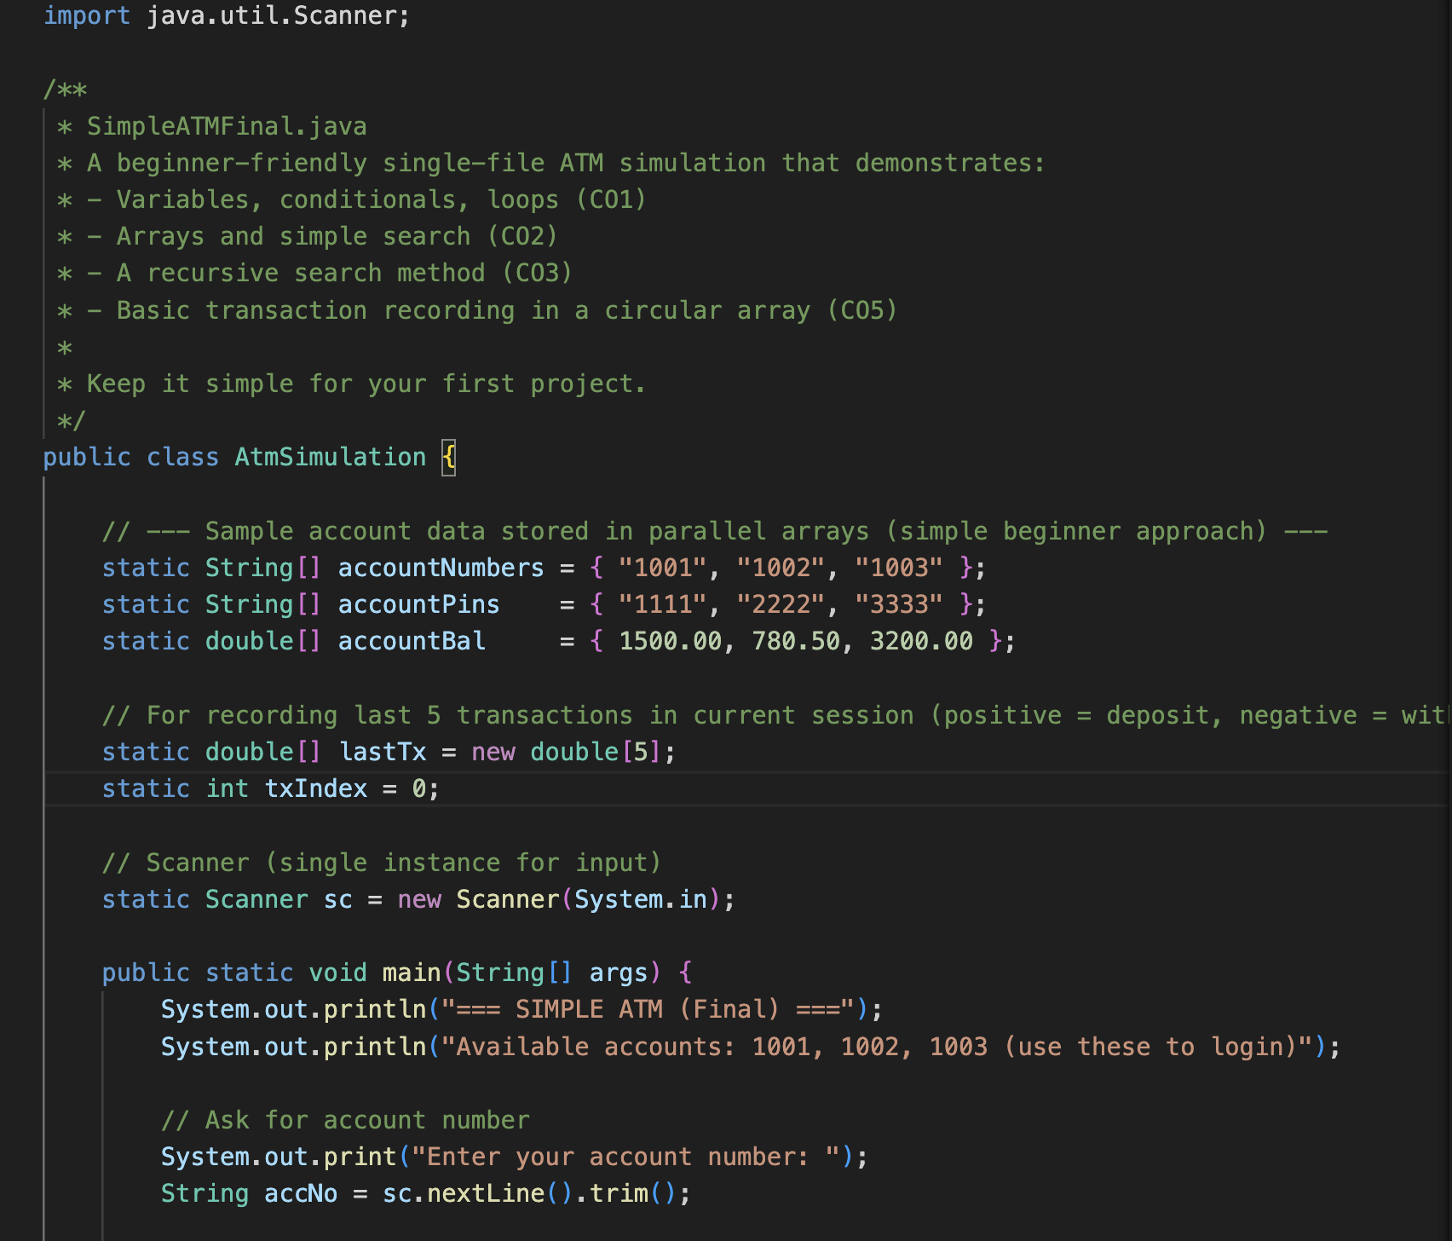

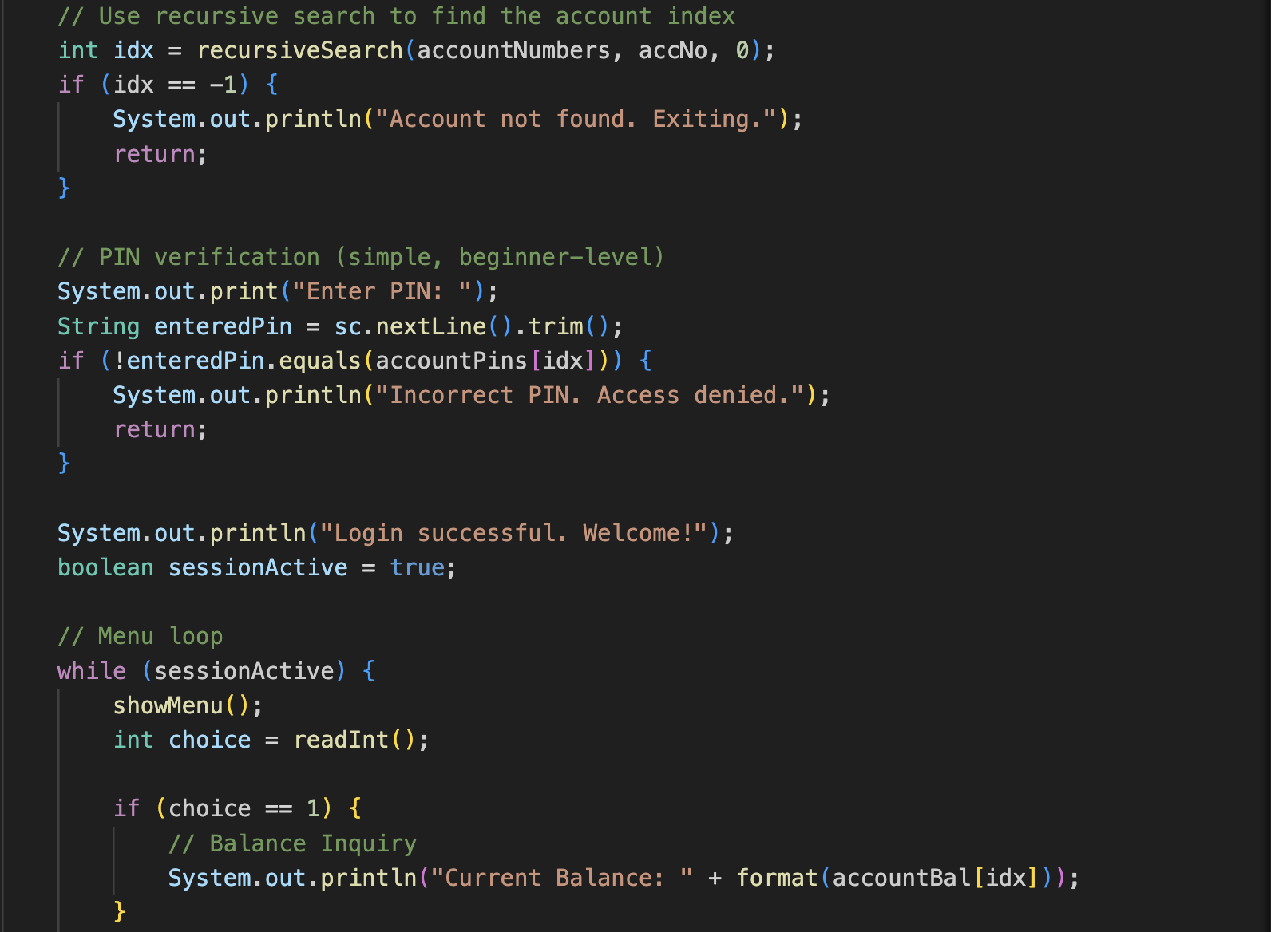

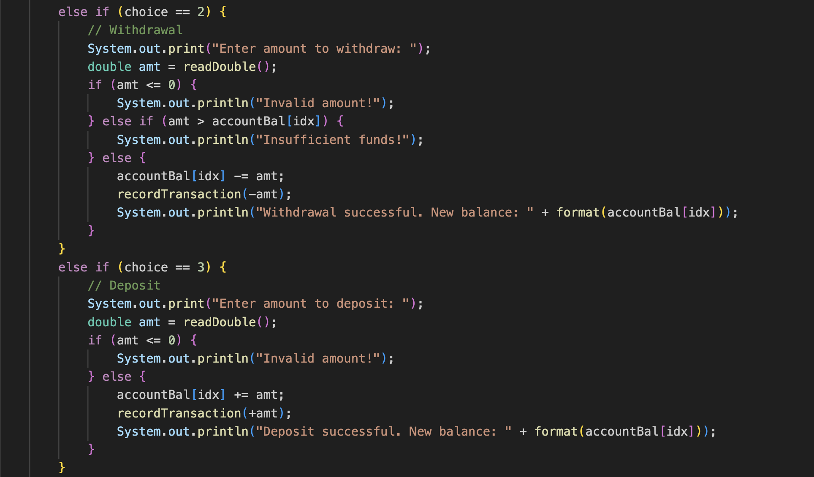

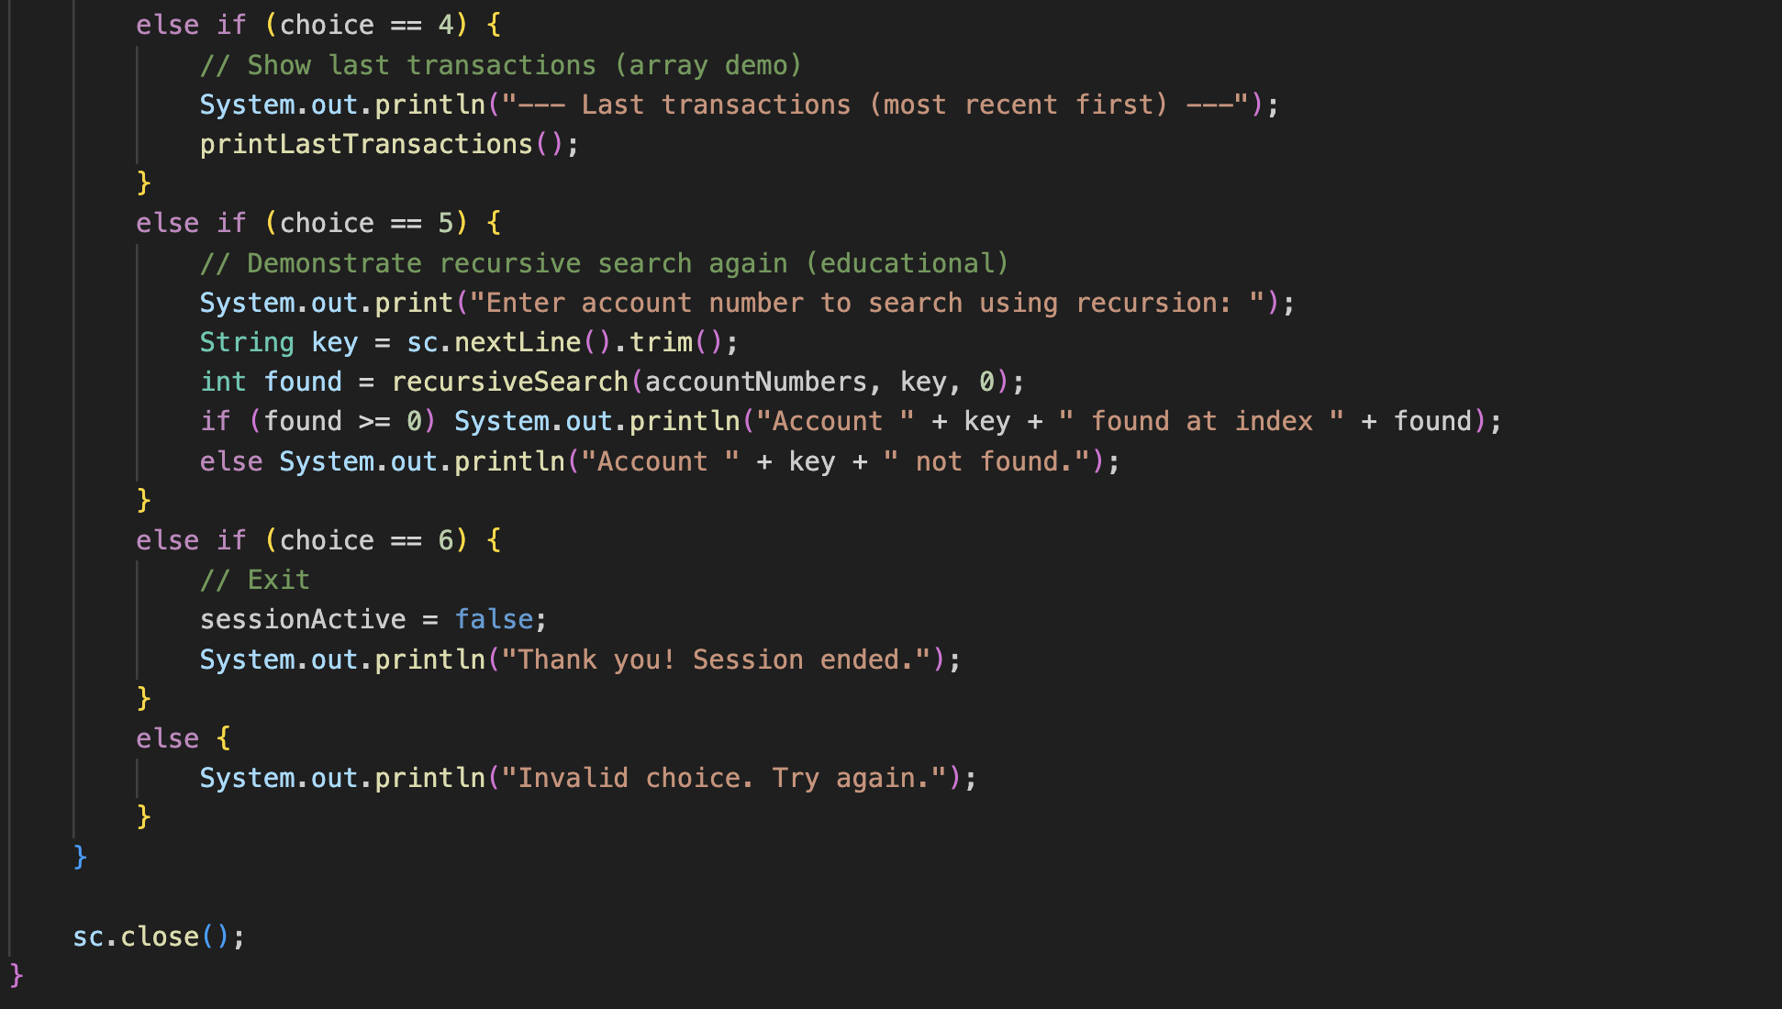

# 

# CHAPTER -5 TESTING

## Test Cases and Results

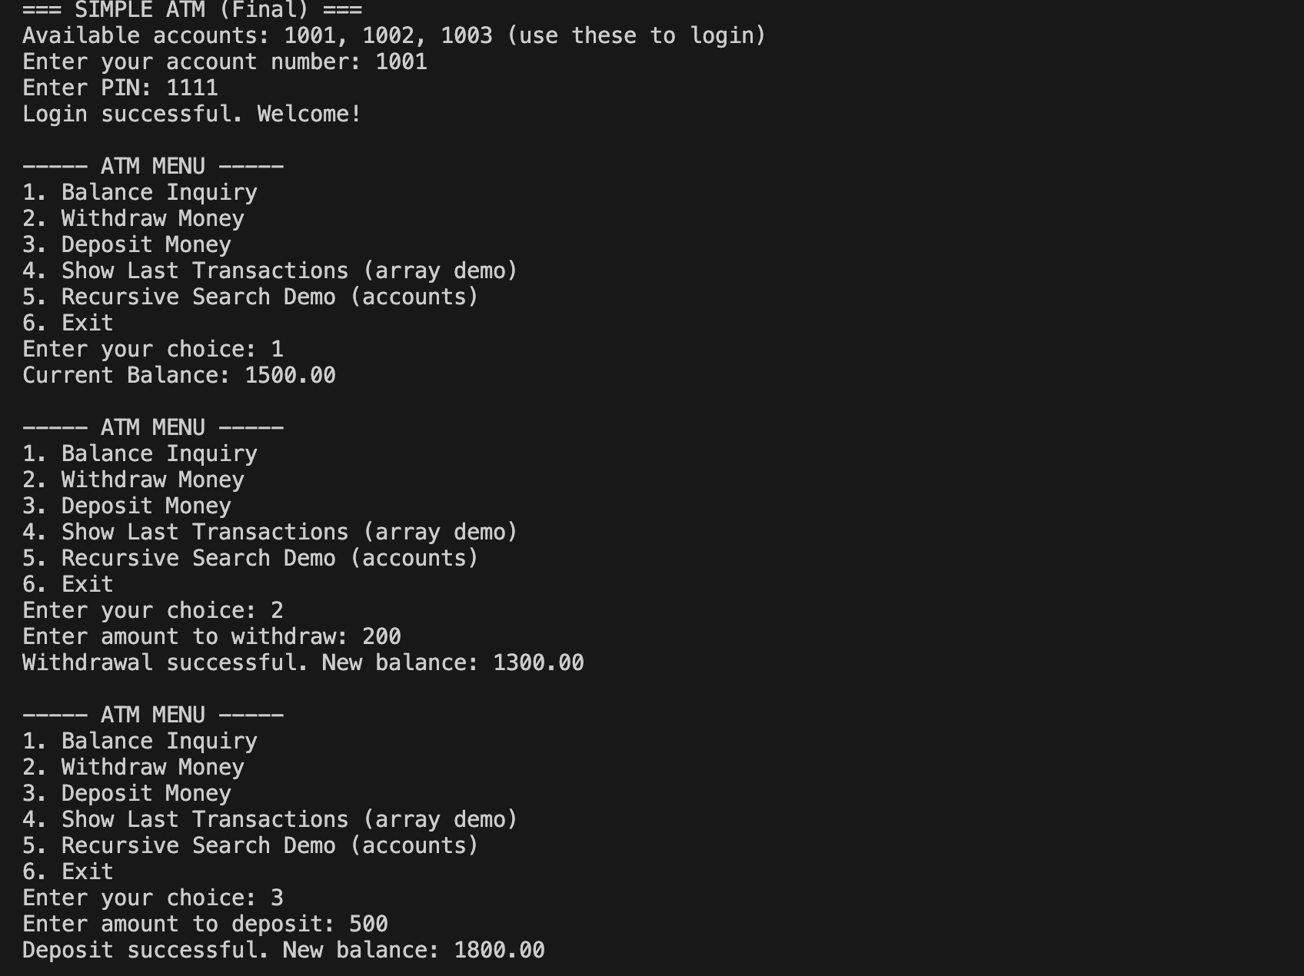

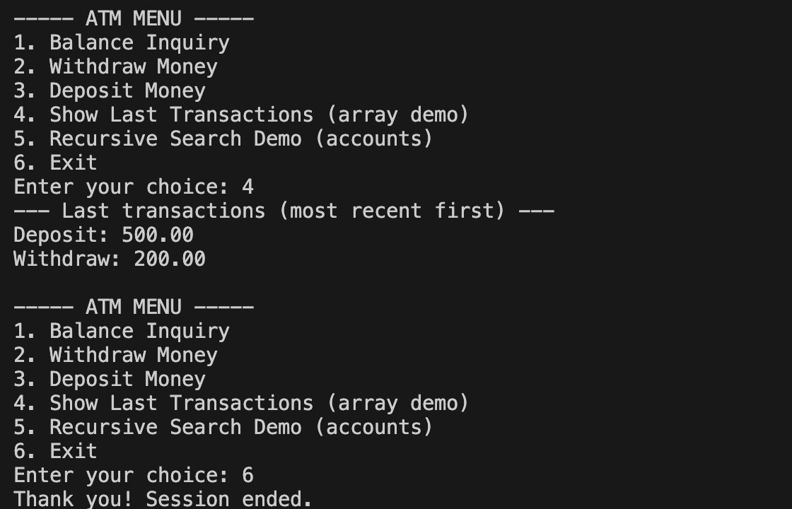

# CHAPTER -6 FUTURE ENHANCEMENTS

## Planned Features

The ATM Simulation system developed in this project is structured in a modular and extensible way, providing strong potential for enhancements in future versions. Several improvements can be incorporated to transform the system from a basic console-based simulation into a fully functional, user-friendly banking application that more accurately reflects real-world ATM behavior.

### **Planned Features**

One of the major enhancements envisioned for this project is the integration of a **graphical user interface (GUI)** using technologies such as JavaFX or Swing. A GUI-based ATM interface would allow users to interact with the system through buttons, panels, and digital card/keypad simulations rather than simple text menus. This would make the ATM feel more realistic and accessible for beginners. Animations for card insertion, cash withdrawal, receipts, and screen transitions can further elevate the user experience.

Another planned enhancement involves expanding the **scope of banking operations**. Future versions can introduce features such as money transfers between accounts, mini-statements, PIN change options, bill payments, mobile recharge, and scheduled transfers. These additions would make the simulation more comprehensive and aligned with functionalities available in modern ATM systems.

From a data-handling perspective, the current project uses in-memory arrays for account and transaction data. Future implementations can integrate:

* **Database systems** (MySQL, SQLite, PostgreSQL)
* **File storage for persistent data**
* **Encrypted PIN and account information**
* **User profiles with multiple linked accounts**

This shift would allow the ATM to preserve user data across sessions, support multiple users, and provide better security and scalability.

To enhance the learning and analytical component of the project, the ATM could include **detailed transaction reports**, downloadable receipts, and monthly statements in formats such as PDF or CSV. Users may also be allowed to print or save receipts, similar to real-world ATMs. Additional security features like OTP verification, account lockout after multiple failed PIN attempts, or biometric simulation can be implemented to reflect modern ATM technology.

Furthermore, the system could be extended into a **network-based ATM simulator**, where multiple ATMs connect to a central banking server. This would allow simulation of simultaneous transactions, concurrency handling, and real-time account synchronization—important concepts in modern distributed banking systems.

To ensure accessibility and reach, the ATM application could evolve into a **mobile or web-based platform**, providing cross-device availability. Features like dark mode, multilingual support, and accessibility options for users with visual impairments could greatly improve usability. For educational purposes, an instructor dashboard or training mode could also be introduced to help students practice ATM operations in a controlled environment.

In the long term, the ATM simulation could incorporate **AI-assisted fraud detection**, **transaction pattern analysis**, or **customer support chatbots** to mimic advanced banking intelligence systems. These insights would not predict user behavior but could simulate common alerts or recommendations seen in real banking applications.

Overall, these enhancements aim to transform the current ATM Simulation from a simple academic tool into a sophisticated, interactive, secure, and feature-rich virtual banking system. The future versions of the system have the potential to serve as a learning platform, a demonstration tool, and a prototype for real-world ATM solutions.

## 

## CHAPTER -7 CONCLUSION

The ATM Simulation project is designed to replicate the core functionalities of an Automated Teller Machine using fundamental programming concepts. By enabling users to perform essential banking operations such as balance inquiry, withdrawal, deposit, and transaction history viewing, the system demonstrates how a real ATM operates in a controlled digital environment. The project integrates key concepts such as loops, conditional statements, arrays, recursion, and exception handling to create a secure and user-friendly simulation. Through this program, users gain practical exposure to banking operations while understanding how computational logic is used to manage financial transactions reliably. Overall, the ATM Simulation serves as an effective educational tool that reinforces core programming principles and introduces the foundational structure of financial software systems.

### **Conclusion**

The ATM Simulation project successfully achieves its objective of modeling real-world ATM processes in a simplified yet meaningful way. The system provides users with an interactive platform to execute banking transactions while ensuring safety through input validation and structured error handling. By integrating modular programming, array manipulation, and recursive search techniques, the project becomes a strong demonstration of how everyday banking operations can be translated into software logic.

The results show that the simulation effectively mirrors essential ATM functions, allowing users to experience digital banking operations without the complexity of a full-scale backend system. Additionally, the implementation of a transaction history log gives users better insight into session-based financial tracking, further enhancing the educational value of the project. This ATM model also establishes a strong foundation for future enhancements, such as adding a graphical user interface, database support, additional banking features, and improved security mechanisms.

Overall, the ATM Simulation stands as a practical, user-friendly, and instructive project that meets all its intended goals. It not only strengthens understanding of programming fundamentals but also introduces learners to the logic behind real-world financial systems, offering ample scope for future development, innovation, and deeper exploration in the field of software engineering.

# CHAPTER -8 REFERENCES

## Books

1. Pressman, R. S., & Maxim, B. R. (2019). *Software Engineering: A Practitioner’s Approach* (8th ed.). McGraw-Hill Education.  
   <https://www.mhprofessional.com/9781260548006-usa-software-engineering-a-practitioner-s-approach-eighth-edition-group>
2. Bloch, J. (2018). *Effective Java* (3rd ed.). Addison-Wesley Professional.  
   <https://www.pearson.com/en-us/subject-catalog/p/effective-java/P200000003590>
3. Sierra, K., & Bates, B. (2005). *Head First Java* (2nd ed.). O’Reilly Media.  
   <https://www.oreilly.com/library/view/head-first-java/0596009208/>
4. Eck, D. J. (2022). *Introduction to Programming Using Java* (Free Online Textbook).  
   <https://math.hws.edu/javanotes/>
5. Liang, Y. D. (2020). *Introduction to Java Programming and Data Structures* (12th ed.). Pearson.  
   <https://www.pearson.com/en-us/subject-catalog/p/introduction-to-java-programming-and-data-structures/P200000004609>

## Tutorials and Online Learning Resources

1. GeeksforGeeks. (2025). Java Programming Language – Concepts, Examples & Practice.  
   <https://www.geeksforgeeks.org/java/>
2. W3Schools. (2025). Java Tutorial – Basics to Advanced.  
   <https://www.w3schools.com/java/>
3. Oracle Java Documentation. (2025). Official Java Platform, Libraries & API Docs.  
   <https://docs.oracle.com/en/java/>
4. Tutorialspoint. (2025). Java Programming Guide.  
   <https://www.tutorialspoint.com/java/>
5. FreeCodeCamp. (2025). Java & OOP Concepts Study Resources.  
   <https://www.freecodecamp.org/news/tag/java/>

## APIs, Tools, IDEs, and Technologies Used

1. Oracle Java SE Development Kit (JDK). (2025).  
   <https://www.oracle.com/java/technologies/downloads/>
2. IntelliJ IDEA Community Edition – JetBrains. (2025).  
   <https://www.jetbrains.com/idea/>
3. Eclipse IDE for Java Developers. (2025).  
   <https://www.eclipse.org/downloads/>
4. Visual Studio Code + Java Extensions Pack. (2025).  
   <https://code.visualstudio.com/docs/java/java-tutorial>
5. GitHub. (2025). Source Code Hosting and Version Control.  
   [https://github.com](https://github.com/)

## Documentation and Research References

1. Oracle: Java Platform Standard Edition Documentation.  
   <https://docs.oracle.com/javase/>
2. Stack Overflow. (2025). Developer Discussions on Java, Arrays, Exceptions & OOP Concepts.  
   <https://stackoverflow.com/questions/tagged/java>
3. Medium – Java Programming Articles & ATM Simulation Tutorials.  
   <https://medium.com/tag/java>
4. ResearchGate. (2025). Papers on ATM Security, Software Models & Banking System Simulations.  
   <https://www.researchgate.net/>
5. IEEE Xplore. (2025). Research Papers on ATM Software, Security, and System Design.  
   <https://ieeexplore.ieee.org/>

# CHAPTER – 9

APPENDICES**

Appendices provide additional information that supports the main content of the ATM Simulation project report. These sections are not always essential to the core explanation but help the reader gain a deeper understanding of the system’s structure, logic, and execution. The following appendices are included for the ATM Simulation project:

## Appendix A: Source Code

This appendix contains the complete source code used to develop the ATM Simulation program. It includes all Java classes, methods, and logic related to account authentication, balance inquiry, withdrawals, deposits, recursive search operations, transaction history recording, and input validation. The code is provided in a clear and well-commented format to help readers understand how each component of the system works internally.

## Appendix B: Sample Input and Output Screenshots

This section provides screenshots of the ATM program running with various inputs. These examples demonstrate how the system behaves during login attempts, withdrawals, deposits, invalid input handling, and viewing the last transaction history. The screenshots serve as a visual reference to confirm correct program execution and user interaction flow.

## Appendix C: Flowchart / Algorithm Used

This appendix presents the flowchart and algorithm representing the logical structure of the ATM Simulation. The flowchart visually outlines major processes such as user login, PIN verification, menu navigation, transaction processing, and program termination. The accompanying algorithm explains the step-by-step sequence of operations used in the simulation, ensuring clarity in the program’s logical design.

## Appendix D: Testing and Validation Report

This section includes detailed test cases used to verify the functionality and reliability of the ATM Simulation system. It covers different scenarios such as:

* Correct and incorrect account numbers
* Valid and invalid PIN entries
* Boundary conditions for withdrawal and deposit amounts
* Invalid input types (letters instead of numbers)
* Transaction history validation

The testing report ensures that the system behaves as expected under all conditions and meets its functional requirements.

## Appendix E: Hardware and Software Requirements

This appendix lists the tools, software, and system specifications required to develop and run the ATM Simulation project. It typically includes:

* Programming Language: Java
* IDE/Compiler: IntelliJ IDEA, Eclipse, or any Java-supporting IDE
* JDK Version: Java SE 8 or later
* System Requirements:
  + Minimum 2 GB RAM
  + Any Windows / macOS / Linux environment
  + Standard keyboard and console interface

These requirements ensure smooth development and execution of the program.

## Appendix F: Project Output Data (Optional)

If the system was tested with multiple user sessions or extended transaction sequences, the resulting output logs may be included here. Examples include:

* Detailed transaction history samples
* Outputs from repeated deposits and withdrawals
* Error-message logs for invalid user entries

This data can help validate the behavior, consistency, and performance of the ATM simulation during testing.

## Appendix G: Bibliography / References

This appendix documents all books, websites, programming tutorials, and research articles that were referenced during the development of the ATM Simulation project. It provides proper acknowledgment of external sources and offers additional reading materials for users or developers who wish to explore the subject further.